**Assignment 11.3**

1. Create your own application by filling the required details

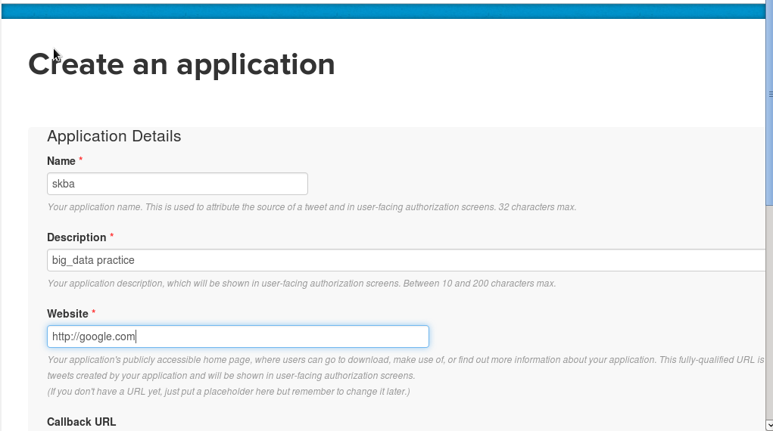

2 When you fill the details you will see the page

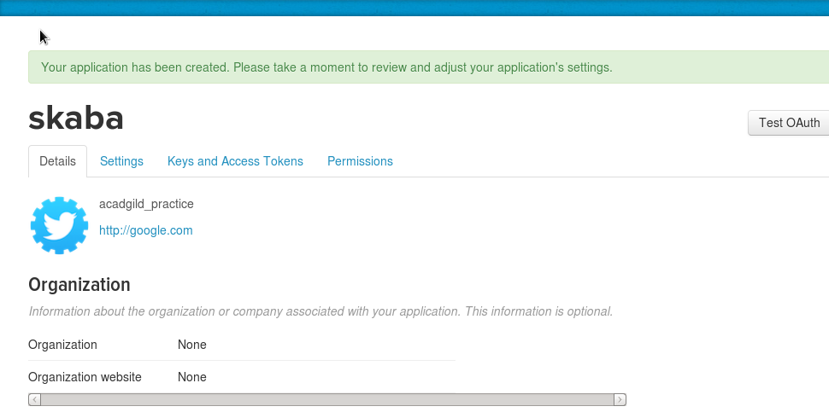

After that go to keys and access token and then copy the key and secret key

After that we will create a file flume.conf inside the conf directory inside flume

And we will write the code as follows

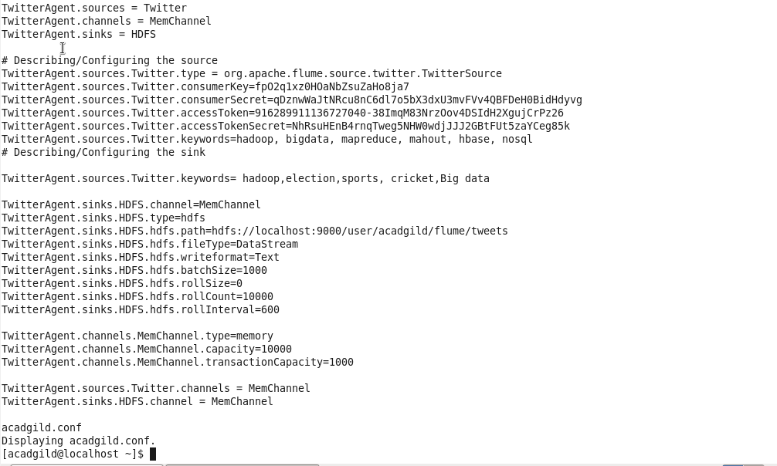

After that we will create a directory inside hdfs



For fetching the tweeter data we will feth the data into hdfs cluster using following command

Flume-ng agent –n TwitterAgent /usr/local/flume/conf/*flume.conf //path of file created inside conf

